Beauty on Credit

How repeat consumption and consumer financing are reshaping the economics of U.S. medical aesthetics
29.8M
U.S. aesthetic procedures in 2024
18.55M
Procedures tied to recurring or maintenance-oriented treatment models
$2K+
Reported purchase size for many elective medical transactions

The Question:
Medical aesthetics sits at an unusual intersection of repeat consumption and high discretionary spending.
Minimally invasive treatments create recurring maintenance cycles, while surgical procedures operate through fewer, substantially higher-value transactions. At the same time, installment financing is expanding into elective medical purchases.
What happens when consumer-credit infrastructure enters a market built on repeat treatments, discretionary spending, and high ticket purchases?
This analysis follows that question across three layers:
Market Structure → Consumption Economics → Consumer Financing

The Repeat Economy
95% of aesthetic procedure volume is minimally invasive.
U.S. aesthetic procedure volume reached approximately 29.8 million in 2024, but the market is far from evenly distributed. Minimally invasive treatments accounted for 94.8% of total procedure volume, while cosmetic surgery represented just over 5%.

9.88M
Neuromodulator procedures in 2024
Neuromodulators alone generated more than 28× the procedure volume of liposuction, the highest-volume cosmetic surgery. But volume tells only part of the story.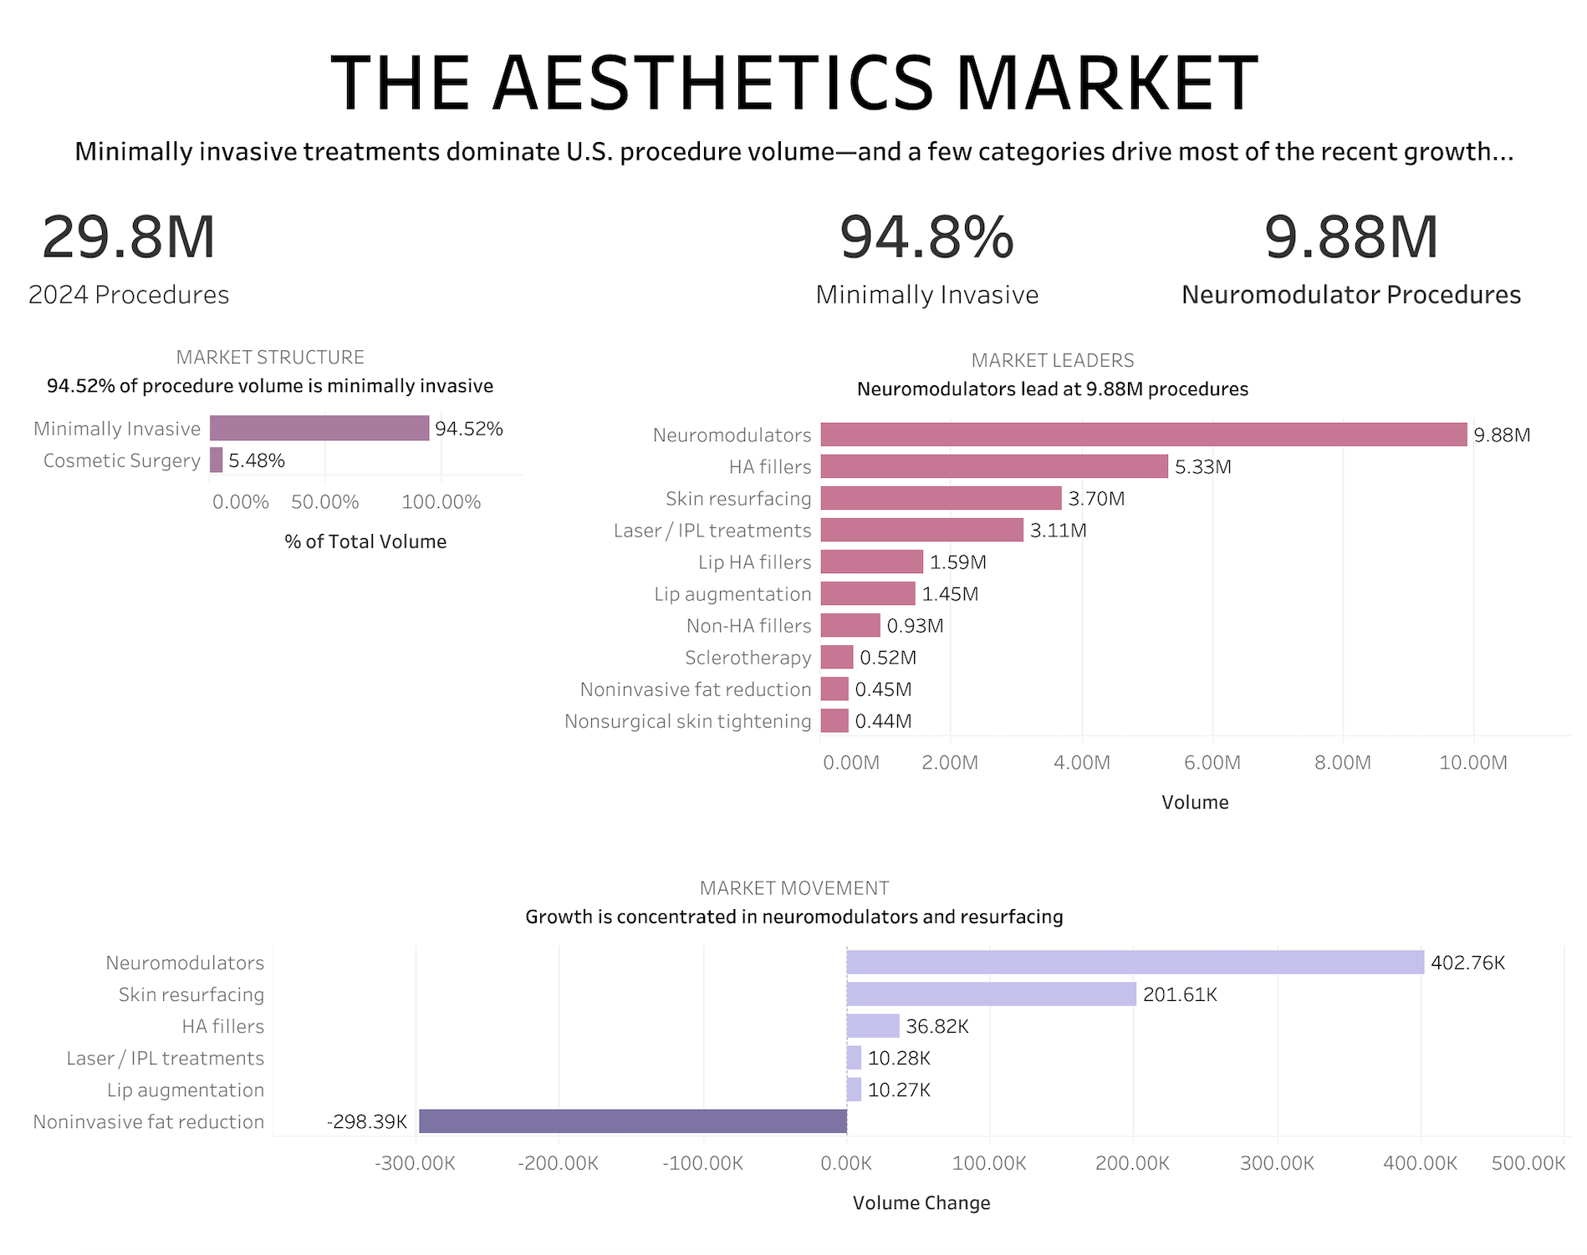

The largest categories are also designed to bring consumers back.
Neuromodulators, fillers, skin resurfacing, and laser-based treatments follow maintenance, repeat-purchase, or treatment-cycle patterns. When procedures are grouped by consumption behavior, 18.55 million procedures fall into recurring or maintenance-oriented models, compared with approximately 1.25 million classified as high-ticket, low-frequency treatments.
The scale of medical aesthetics is driven not only by procedure demand, but by repeat consumption. For minimally invasive treatments, the customer relationship often continues after the first transaction—making retention, rebooking, and treatment frequency part of the underlying economics.

Two Economic Engines
Medical aesthetics monetizes consumers in two fundamentally different ways.
High procedure volume does not necessarily mean high transaction value. Among procedures with available pricing data, cosmetic surgery averaged approximately $8,049 per procedure, compared with approximately $638 for minimally invasive treatments. But minimally invasive treatments operate at a dramatically greater scale and are more likely to generate repeat visits.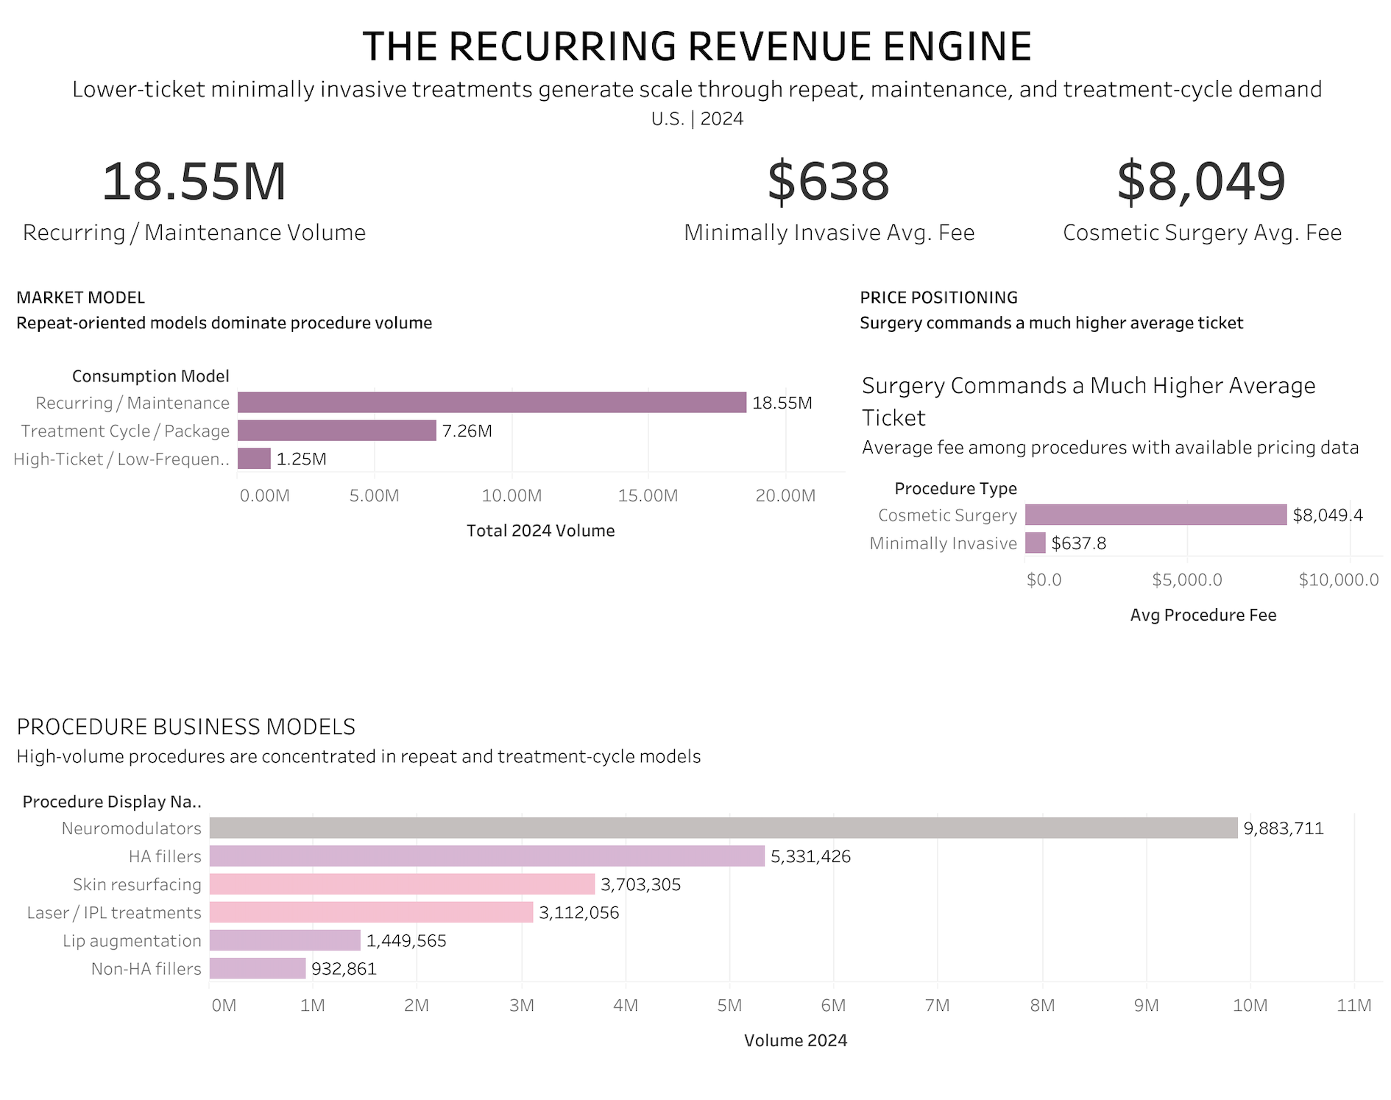

REPEAT ENGINE
High Volume · Lower Ticket · Recurring
Minimally invasive treatments
18.55M recurring / maintenance-oriented procedures
≈ $638 average available procedure fee
Primary growth levers: Retention → Rebooking → Treatment Frequency → Cross-Sell

HIGH-TICKET ENGINE
Lower Volume · Higher Ticket · Episodic
Cosmetic surgery
1.25M high-ticket / low-frequency procedures
≈ $8,049 average available procedure fee*
Primary growth levers: Lead Generation → Consultation → Conversion → Transaction Value

Same industry. Different economics.
For repeat-oriented treatments, value accumulates through frequency and customer retention. For surgery, value is concentrated in fewer, substantially larger transactions.
That distinction changes how aesthetic businesses should think about customer acquisition, lifecycle marketing, and long-term value. Pricing represents average fees among procedures with available pricing data. Coverage was 87.5% for cosmetic surgery and 36.4% for minimally invasive procedures.

Credit Enters the Equation

What happens when financing enters a market built on discretionary spending?
Medical aesthetics combines two characteristics that make payment structure particularly relevant: repeat spending and meaningful upfront costs. At the same time, installment-based payment methods have become more common in the broader consumer-credit market.
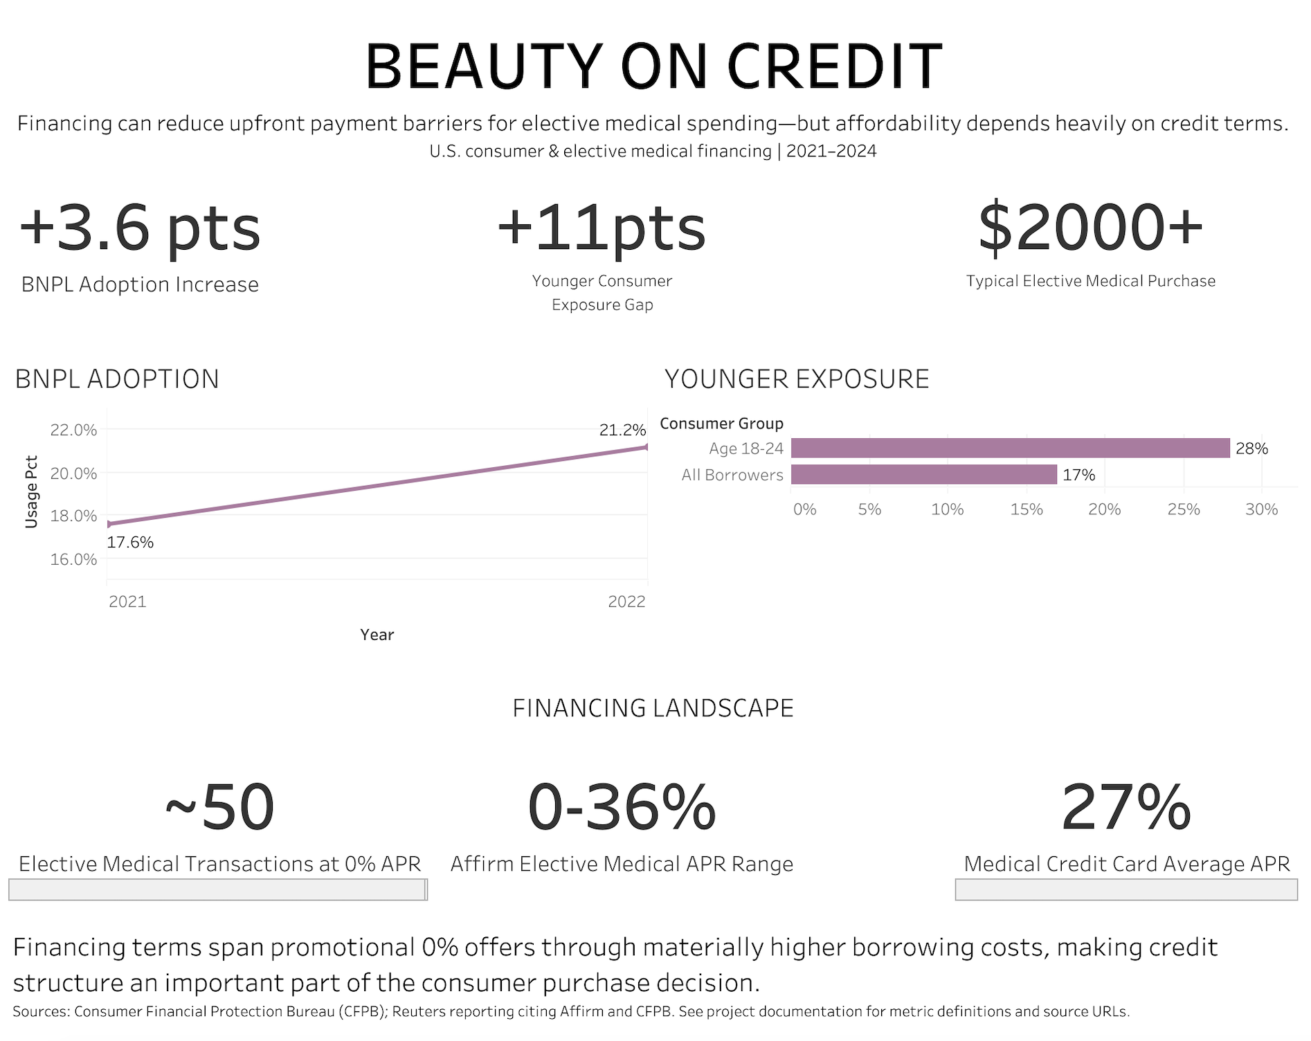

Financing Is Moving Into Elective Medical Spending
By the end of 2023, Affirm had approximately 130 elective-medical merchants in its network—more than double the prior year—across categories including cosmetic treatments, dental services, and medical devices. The purchases are not necessarily small. Many elective-medical transactions were reported at $2,000 or more, while financing terms ranged from 0% to 36% APR. Nearly half of transactions in the category were reported at 0% APR.
For consumers, this introduces another way to approach a relatively expensive discretionary purchase: instead of paying the full cost upfront, the purchase can be spread across installments.

17.6% → 21.2%
Consumers using BNPL, 2021–2022
At the same time, installment payments were becoming more common in the broader consumer market. BNPL usage increased from 17.6% in 2021 to 21.2% in 2022, a 3.6-percentage-point increase. The important point is not that these consumers were financing aesthetic procedures—the data cannot tell us that. It is that elective-medical financing is expanding in a market where consumers are already becoming more familiar with installment-based payments.

28% vs. 17%
BNPL share of unsecured debt during months of BNPL use
The role of BNPL also looks different across age groups. Among consumers ages 18–24, BNPL accounted for 28% of unsecured debt during months when they used BNPL, compared with 17% among borrowers overall. That gap makes financing terms particularly important when credit moves into discretionary categories. Easier access to installments may reduce the amount due today, but it can also change how consumers experience and evaluate the cost of a purchase.

Financing changes how consumers pay—not what a procedure costs.
This is where the two sides of the analysis come together. Medical aesthetics already combines repeat-oriented treatments with meaningful discretionary spending. Now, financing infrastructure is increasingly extending into elective medical purchases. Installments can make a $2,000+ purchase easier to manage at the point of sale by spreading the cost over time. But a smaller payment today does not necessarily mean a more affordable purchase overall—especially when financing terms can range from 0% to 36% APR. For aesthetic businesses, financing therefore becomes more than a payment method. It becomes part of the purchase journey, alongside procedure price, treatment frequency, and perceived value.
Scope note: The BNPL data reflects the broader consumer-credit market and does not show that BNPL borrowers used financing specifically for aesthetic procedures. This analysis identifies where two trends intersect—repeat-oriented aesthetic consumption and expanding elective-medical financing—but does not establish that financing caused additional procedure demand.

From Insight to Strategy

The data points to three different growth levers.

1. Treat recurring procedures as a retention business.
For high-frequency treatments, growth does not end at customer acquisition. Rebooking, treatment reminders, memberships, personalized treatment cycles, and cross-category recommendations can increase the value of an existing customer relationship over time.
Business priority: Retention · Rebooking · Frequency · Customer Lifetime Value

2. Match acquisition strategy to procedure economics.
A consumer considering a $600 treatment and one considering an $8,000 surgery represent fundamentally different conversion journeys. Repeat-oriented treatments benefit from lower-friction acquisition and lifecycle engagement, while high-ticket procedures require greater emphasis on consultation quality, trust, lead qualification, and conversion.
Business priority: Segmentation · Funnel Strategy · Lead Quality · Conversion

3. Use financing as a conversion tool, not a substitute for affordability.
Financing can reduce upfront payment friction, particularly for higher-ticket elective procedures. But APR variation means that monthly-payment accessibility and true affordability are not equivalent. Operators should therefore evaluate financing not only by approval or adoption rates, but by how payment options interact with conversion, procedure mix, and consumer financial risk.
Business priority: Payment Friction · Conversion · Financing Mix · Responsible Growth
The bigger picture
Medical aesthetics is not one business model. It sits at the intersection of recurring consumption, high-ticket discretionary spending, and an expanding consumer-financing infrastructure. Understanding which economic engine drives each procedure is therefore essential to deciding how to acquire, retain, and monetize customers.

Sources & Methodology & Technical Appendix
Sources & Methodology
Procedure volume and pricing data were sourced primarily from the American Society of Plastic Surgeons (ASPS). Consumer-credit metrics were sourced from the CFPB, while Reuters reporting on Affirm's expansion into elective medical financing provided the bridge between the aesthetics and financing analyses. Treatment-frequency classifications were developed for this project using published clinical and professional information.
Scope note: Consumer BNPL data reflects the broader U.S. credit market and does not establish aesthetic-specific borrowing behavior or causality.
TOOLS
MySQL · DBeaver · Tableau

METHODS
Market Sizing · Growth Analysis · Business Segmentation
Pricing Analysis · Data Coverage Validation

SELECTED SQL

Ranking Category Leaders
WITH ranked_procedures AS (
SELECT
year,
procedure_type,
procedure_name,
volume,
DENSE_RANK() OVER (
PARTITION BY year, procedure_type
ORDER BY volume DESC) AS ranking
FROM procedure_volume)
SELECT
year,
procedure_type,
procedure_name,
volume,
ranking
FROM ranked_procedures
WHERE ranking <= 5
ORDER BY year, procedure_type, ranking;

Identifying Growth Drivers
WITH procedure_growth AS (
SELECT
year,
procedure_type,
procedure_name,
volume,
LAG(volume) OVER (
PARTITION BY procedure_name
ORDER BY year) AS previous_volume
FROM procedure_volume)
SELECT
procedure_type,
procedure_name,
previous_volume,
volume AS current_volume,
volume - previous_volume AS volume_change,
ROUND(
(volume - previous_volume) * 100.0/ previous_volume,2) AS growth_pct
FROM procedure_growth
WHERE year = 2024
AND previous_volume IS NOT NULL
ORDER BY volume_change DESC;

Building the Consumption Model
WITH procedure_economics AS (
SELECT
pv.procedure_name,
pv.procedure_type,
pv.volume,
pr.business_model,
pp.average_fee_usd,
CASE
WHEN pr.business_model IN ( 'Recurring revenue', 'Repeat purchase', 'Recurring service', 'Maintenance spending') THEN 'Recurring / Maintenance'
WHEN pr.business_model IN ( 'Package-based consumption', 'Procedure package spending') THEN 'Treatment Cycle / Package'
WHEN pr.business_model IN ( 'High-ticket one-time purchase', 'High-ticket purchase with future revision potential') THEN 'High-Ticket / Low-Frequency'
END AS consumption_model
FROM procedure_volume pv
JOIN procedure_recurrence pr
ON pv.procedure_name = pr.procedure_name
LEFT JOIN procedure_pricing pp
ON pv.procedure_name = pp.procedure_name
WHERE pv.year = 2024)
SELECT
consumption_model,
COUNT(*) AS procedure_count,
SUM(volume) AS total_2024_volume,
ROUND(AVG(average_fee_usd), 2) AS avg_available_fee
FROM procedure_economics
WHERE consumption_model IS NOT NULL
GROUP BY consumption_model
ORDER BY total_2024_volume DESC;

